Directions: Read this article about a well-known landscape architect. Then answer questions 1 through 6.
Frederick Law Olmsted
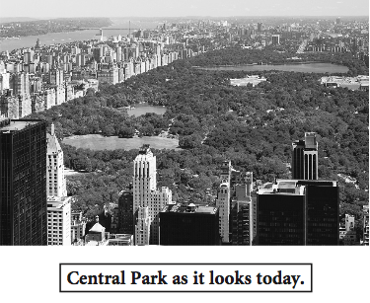

Frederick Law Olmsted was born on April 26, 1822, and grew to become nineteenth-century America’s number one landscape architect. Bad eyesight forced him to abandon his plans to attend university, so he had to choose a new course for his life. As a boy in Hartford, Connecticut, he had always admired natural beauty. So, instead of studying academics, he decided instead to focus on engineering and farming. In the 1850s, he ended up in charge of creating Central Park in New York City.

Olmsted and a partner entered a design contest for a new park and won with a design patterned after gardens and natural sights that Olmsted had admired around the world. To create the new park, they shifted nearly 5 million cubic yards of dirt, blasted rock with 260 tons of gunpowder, and planted 270,000 trees and shrubs. In 1864, New Yorkers could stroll along wooded paths, paddle a boat around the lake, or people-watch from terraces. Today, many people cannot imagine New York City without its Central Park.
Maybe it was watching those people enjoy his creation that inspired Olmsted. He became one of the first commissioners of Yosemite National Park because he was determined to protect its breathtaking beauty. He did the same for Niagara Falls and helped turn it into a public reserve. Working well into his seventies, Olmsted designed more parks and even an entire Chicago suburb, Riverside. And to think that bad eyesight led him to create such beautiful places.
GO ON

1. According to information in the article, the main benefit of Frederick Law Olmsted’s extensive travels was that they
A gave him new ideas for project designs
B taught him to rely on others for support
C reminded him of his love for his home town
D encouraged him to correct his poor eyesight

2. Which feature would Frederick Law Olmsted most likely have thought important to include in a park?
F outdoor theater
G flower gardens
H basketball court
J concession stands

3. Look at the outline below.
Frederick Law Olmsted
I. Became landscape architect
A. Created Central Park
B. Became commissioner of Yosemite National Park
C. ____________________________
D. Designed Chicago suburb

Based on information in the article, choose the phrase that belongs in the outline.
A Planted 270,000 trees and shrubs
B Studied engineering and farming
C Turned Niagara Falls into a public reserve
D Shifted nearly 5 million cubic yards of dirt

4. Based on information in the article, readers can conclude that Frederick Law Olmsted was
F hard-working
G smooth-talking
H snobbish
J unreliable

5. With which statement would Frederick Law Olmsted most likely agree?
A Funding for public parks should be reduced.
B It is a waste of time to enter drawing contests.
C Everyone must earn a college degree to succeed.
D Beautiful parts of the natural land should be preserved.

GO ON

6. Look at the sample index below.

Olmsted, Frederick Law 75–88
Childhood 75–76
Conservation 87–88
Education 77–78
Projects 79–83

On which pages would you most likely find more information on Frederick Law Olmsted’s design for Central Park?
F 75–76
G 77–78
H 79–83
J 87–88
STOP

